研究生自助打印系统操作指南
一、使用前注意 Attention Before Use
使用自助打印机前，必须先在本人研究生管理系统内维护英文姓名和生日（如王佳奇，英文姓名为WANG Jiaqi，生日格式为19900321）。维护需点击研究生管理系统内的“学生学籍信息”功能。
You need maintain your English name and birthday in your Graduate Management System first before use（Format as NAME-‘WANG Jiaqi’，BIRTHDAY-‘19900321’）.

二、选择语言 Choose the Language
在主屏幕下，轻触屏幕，进入语言选择界面。Click on the screen and choose the language you like.
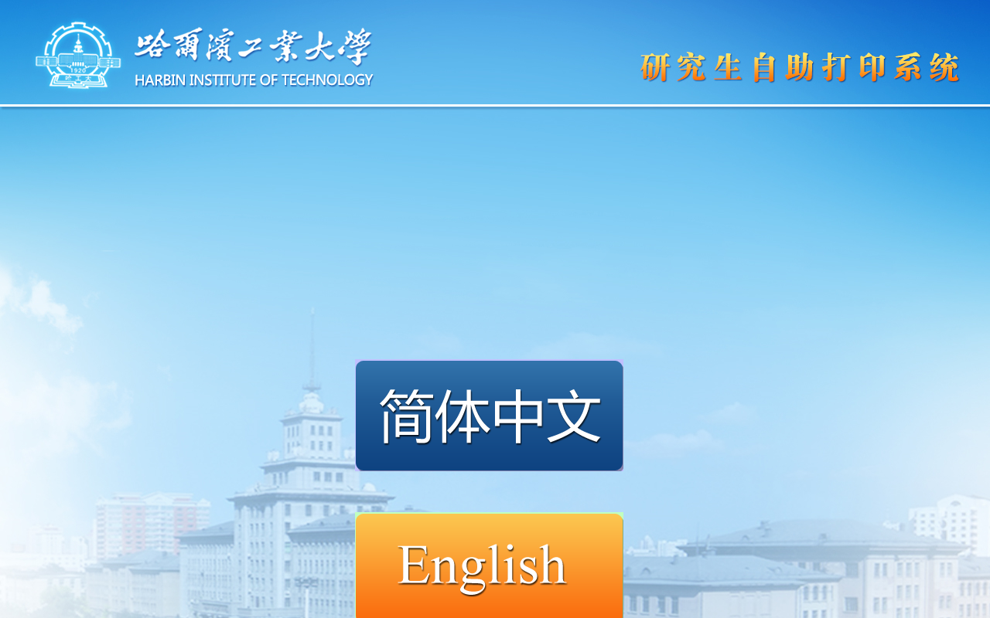

三、选择登录方式 Choose how to Login
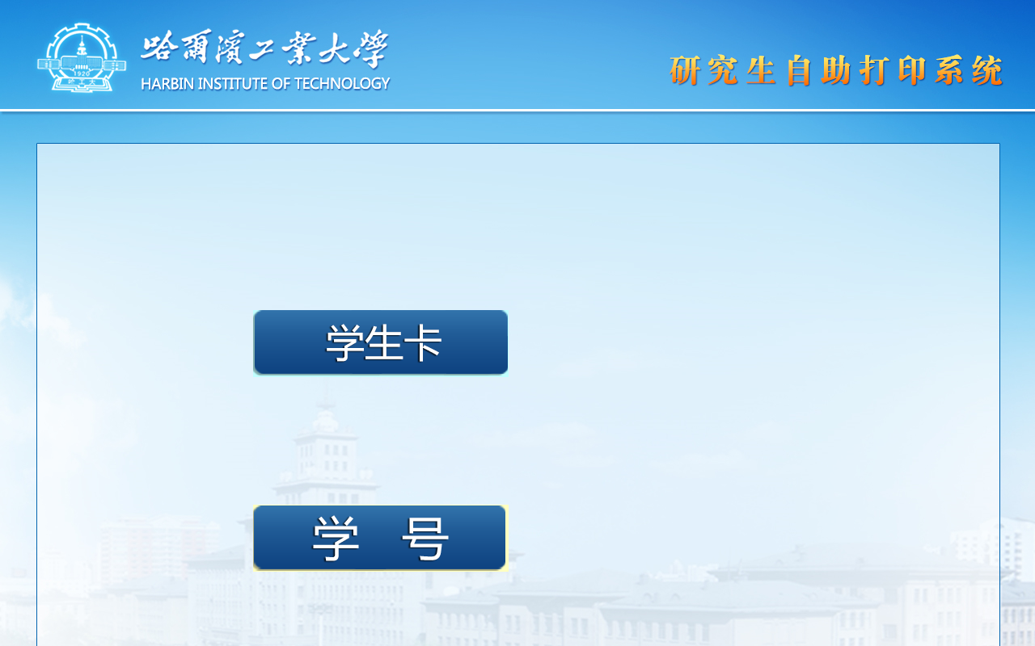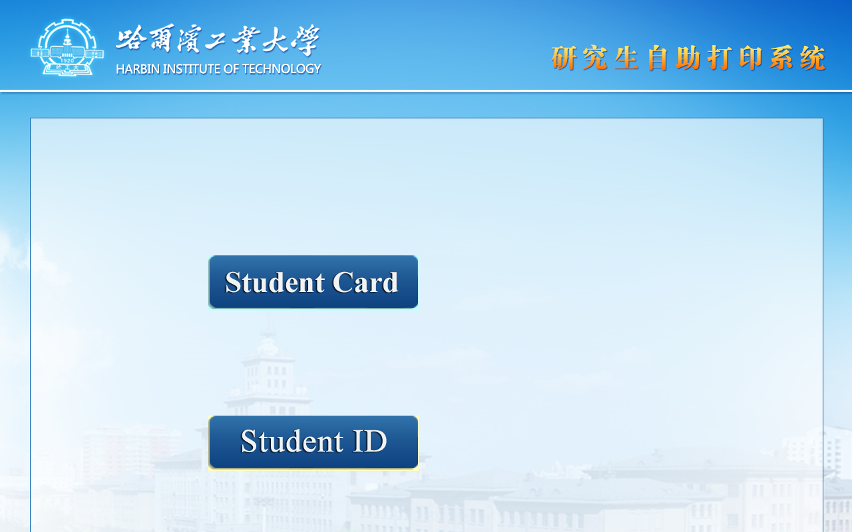
1、学生卡登录 Student ID Card
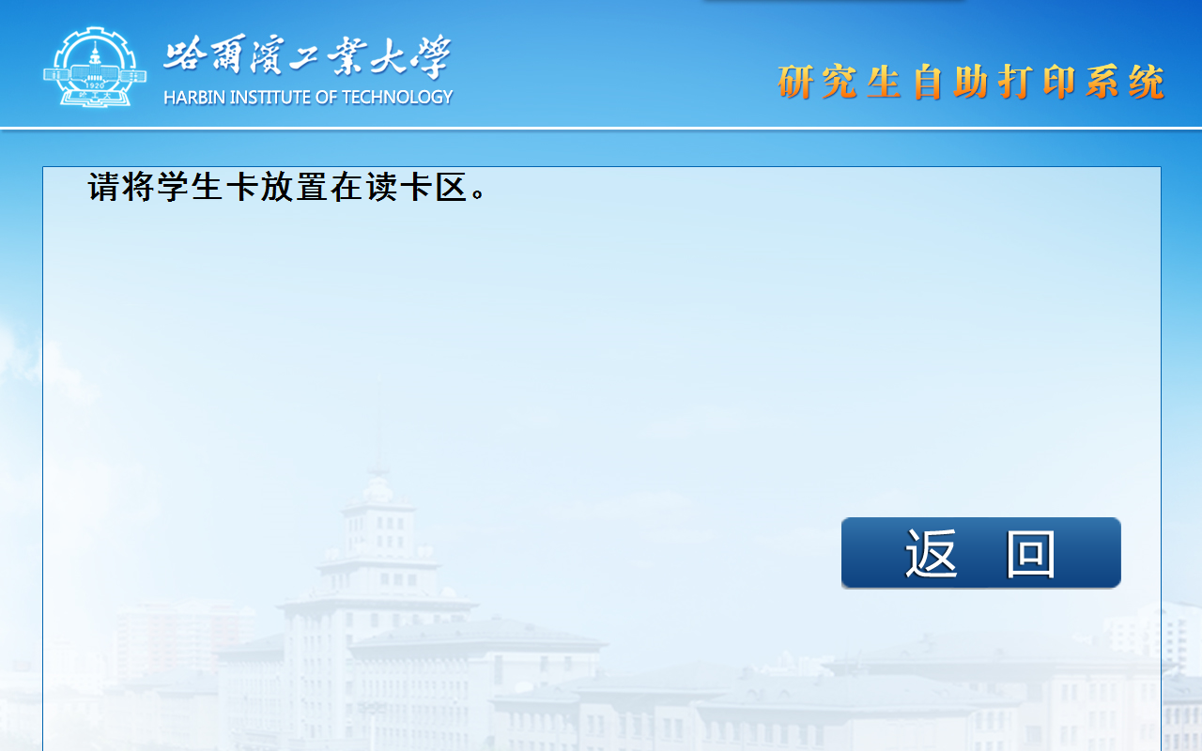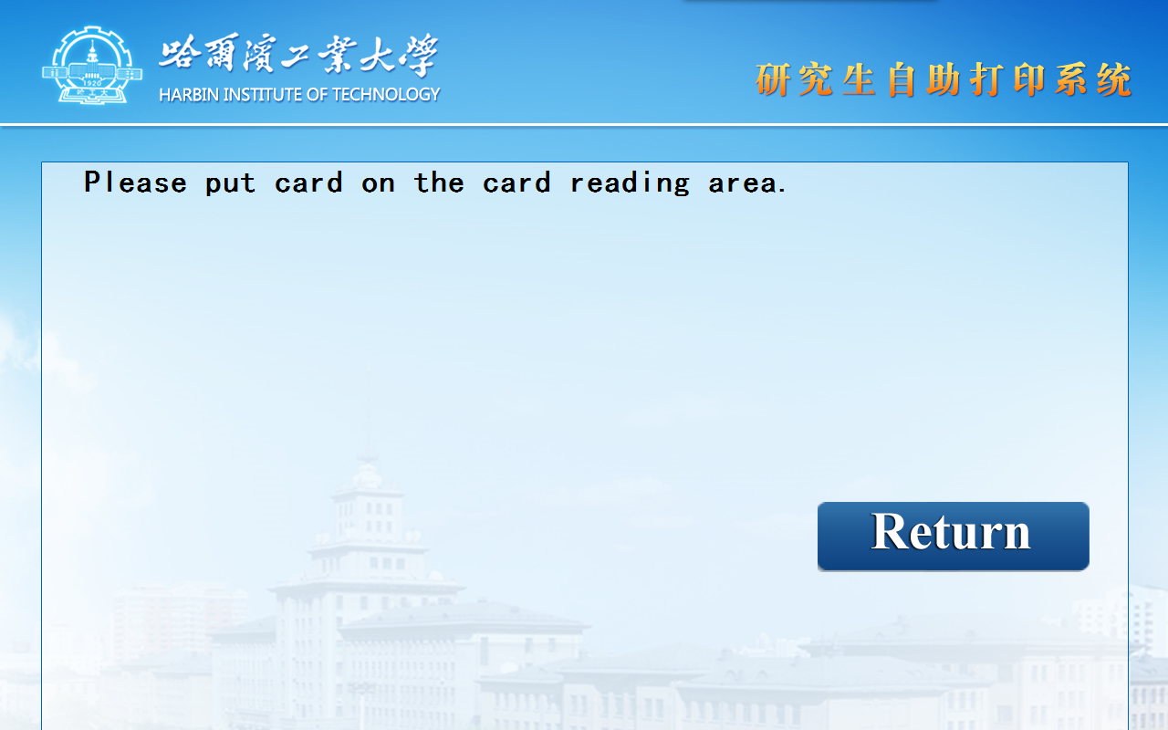

2、学号登录 Student ID and Password
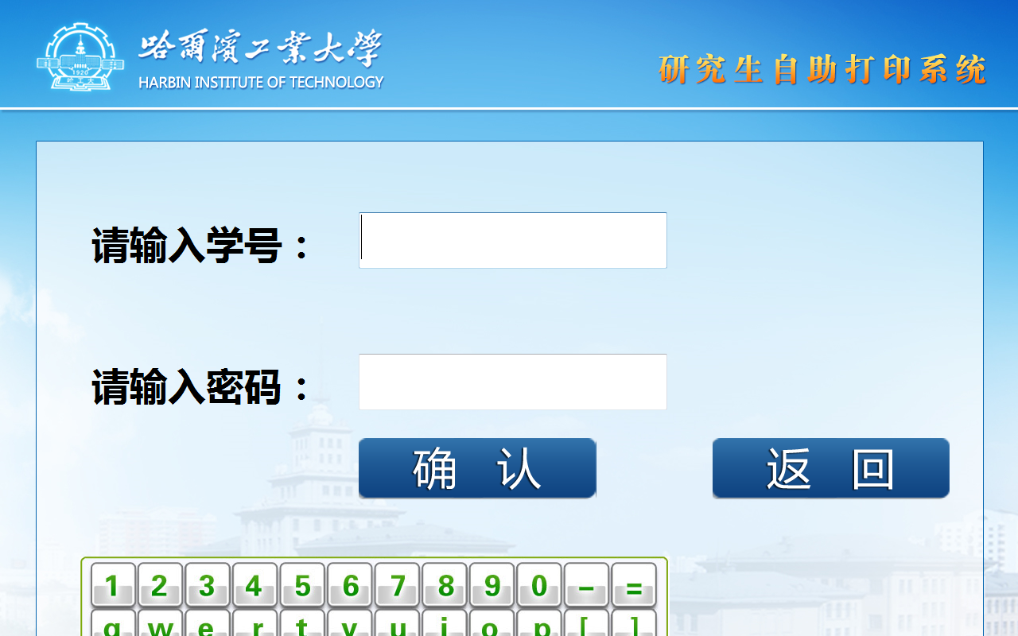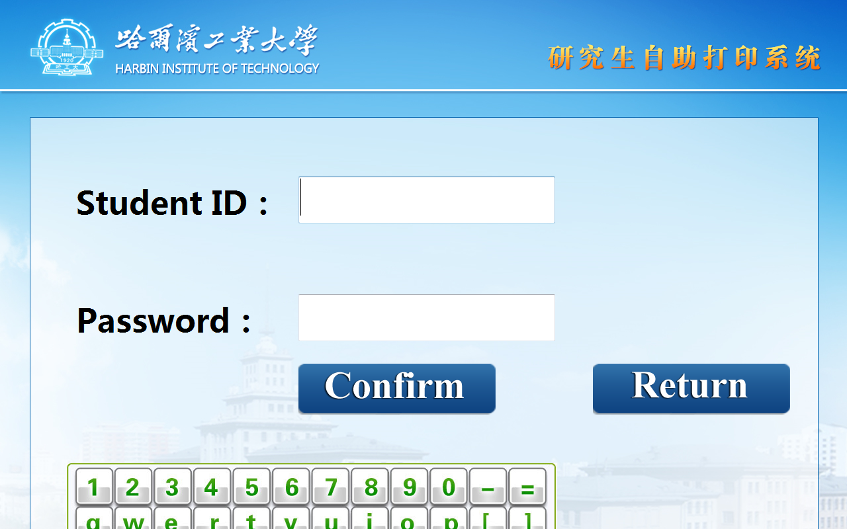
请凭学号和研究生管理系统密码登录，注意区分大小写。
The password is the same as yours in Graduate Management System.
3、键盘说明 Instruction for Keyboard
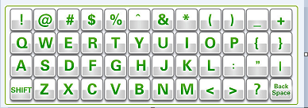
左下SHIFT可切换大小写，右下BackSpace为退格删除。
Click left SHIFT to switch case, Click right BackSpace to delete.
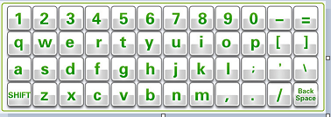
四、核实信息 Information Check
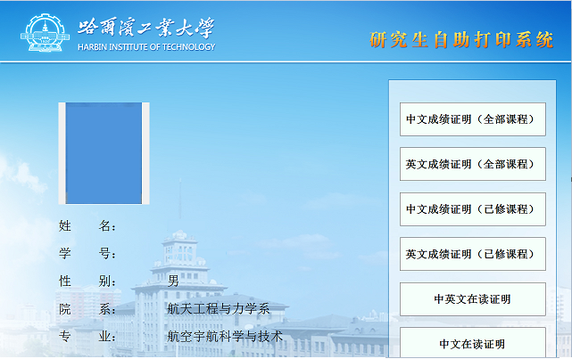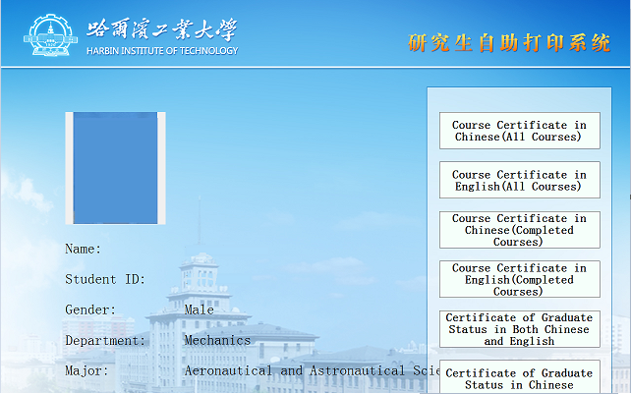
请核实您的身份信息是否正确。Check on your Information

五、成绩证明打印 Course Certificate
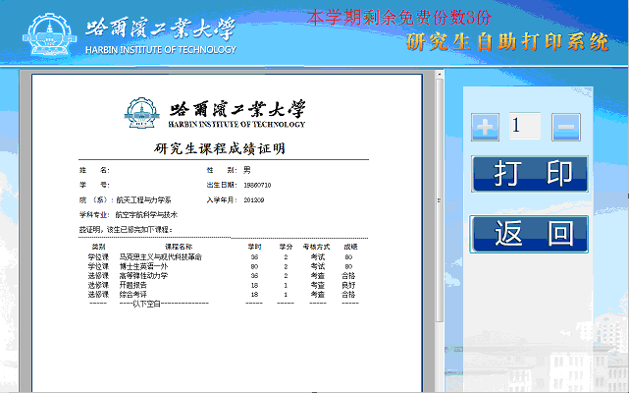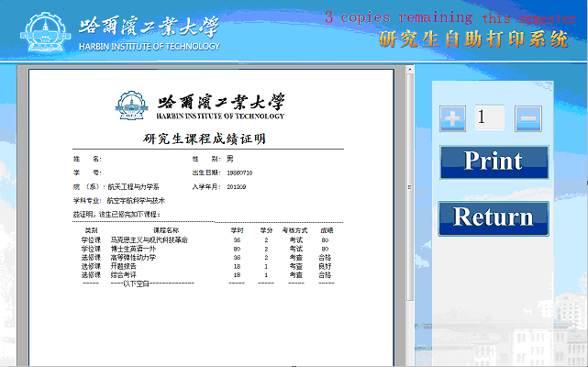
屏幕顶端提示了您可打印的最多份数，例如上图提示的“剩余免费份数3份”，可以通过加号（+）减号（-）来设置您要打印的份数。请根据您的真实需要打印，避免浪费。点击“打印”，即开始打印，稍后请伸手从取纸口取纸。打印完毕，请退出登录，避免个人信息泄露。
The number of copies you can print is on the top of the screen. You can press (+) or (-) to set the number of copies you need print at present. Click ‘print’ to print, please get out the paper later on. When finished printing, Click ‘Return’ , then ‘exit’ to log out.

六、在读证明打印Certificate of Graduate Status
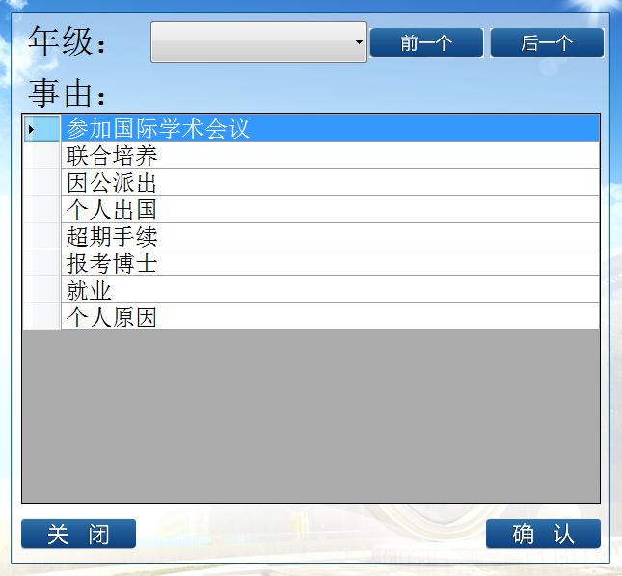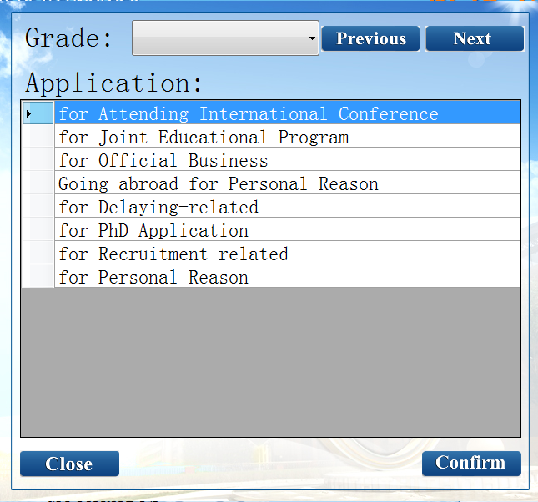
请您注意选择自己所处的年级和证明用途。选择后，点击确认按钮。
Choose your grade and purpose. Then Confirm.
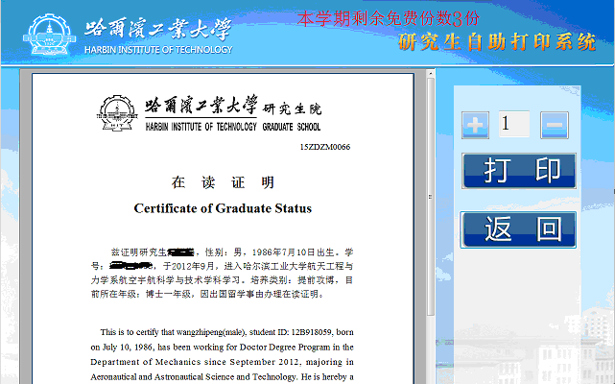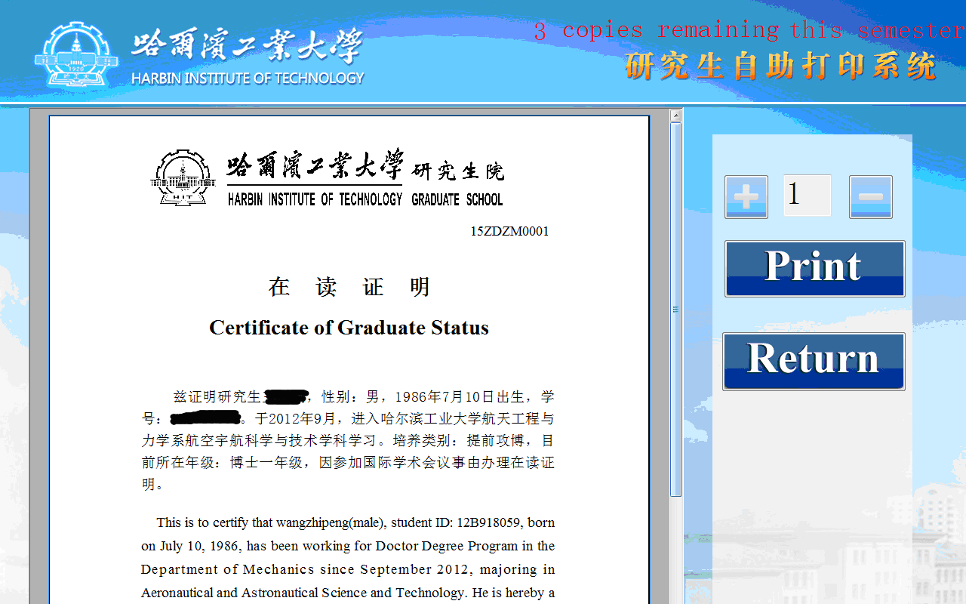
后续操作，与步骤五相同。The other procedures are the same as Course Certificate.

